Chapter 3, Problem 84.

Calculate v_{o} and i_{o} in the circuit of Fig. 3.121.

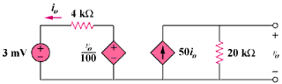
15 mV

Figure 3.121
For Prob. 3.84.

